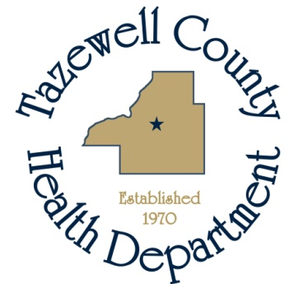

News Release

For Immediate Release For more information contact:
January 2, 2019 Sara Sparkman
@ 309-929-0264

January is Cervical Cancer Awareness Month, and Tazewell County Health Department (TCHD) wants you to know that there’s a lot you can do to prevent cervical cancer. Each year, more than 11,000 women in the United States get cervical cancer.
HPV (human papillomavirus) is a very common infection that spreads through sexual activity, and it causes almost all cases of cervical cancer. About 79 million Americans currently have HPV, but many people with HPV don’t know they are infected.
The good news?
- The HPV vaccine (shot) can prevent HPV.
- Cervical cancer can often be prevented with regular screening tests and follow-up care.
In honor of National Cervical Cancer Awareness Month, TCHD offers free cervical screening for uninsured and underinsured women, ages 35-64, living in Marshall, Peoria, Tazewell and Woodford county. “Prevention and early detection are very important to preventing cervical cancer. I am proud that TCHD offers the HPV vaccine to youth and cervical cancer screening to eligible women,” states Amy Fox, TCHD Administrator.
TCHD encourages parents to make sure pre-teens get the HPV vaccine at age 11 or 12 and offers the vaccine at their walk-in clinics. Teens and young adults also need to get the HPV vaccine if they didn’t get it as pre-teens. Women up to age 26 and men up to age 21 can still get the vaccine.
For more information, visit www.tazewellhealth.org.

