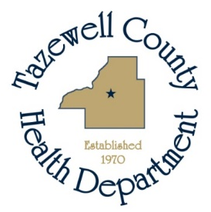

Media Alert

For Immediate Release For more information contact:
September 13, 2019 Sara Sparkman
309-929-0264

WEST NILE VIRUS IN TAZEWELL COUNTY

The Tazewell County Health Department (TCHD) has confirmed the first mosquitoes to test positive for West Nile virus in Tazewell County for 2019. TCHD staff collected mosquitoes testing positive in September in Creve Coeur.

West Nile virus is transmitted through the bite of a Culex pipiens mosquito, commonly called a house mosquito, that has picked up the virus by feeding on an infected bird. Common symptoms include fever, nausea, headache and muscle aches. Symptoms may last from a few days to a few weeks.

“Four out of five people infected with West Nile virus will not show any symptoms,” says Evelyn Neavear, TCHD Environmental Health Director. “In rare cases, severe illness including meningitis or encephalitis, or even death, can occur. People older than 50 and individuals with weakened immune systems are at higher risk for severe illness from West Nile virus.”

Precautions include practicing the three “R’s” – reduce, repel, and report.

- REDUCE - make sure doors and windows have tight-fitting screens. Repair or replace screens that have tears or other openings. Try to keep doors and windows shut.

Eliminate, or refresh each week, all sources of standing water where mosquitoes can breed, including water in bird baths, ponds, flowerpots, wading pools, old tires, and any other containers.

- REPEL - when outdoors, wear shoes and socks, long pants and a long-sleeved shirt, and apply insect repellent that contains DEET, picaridin, oil of lemon eucalyptus, or IR 3535 according to label instructions. Consult a physician before using repellents on infants.

- REPORT – report locations where you see water sitting stagnant for more than a week such as roadside ditches, flooded yards, and similar locations that may produce mosquitoes. The local health department or city government may be able to add larvicide to the water, which will kill any mosquito eggs.

Additional information about West Nile virus can be found on the IDPH website.

# # #

